This is a brief introduction to Professional Learning Communities and collaborative teams work flow. Collaborative teams work interdependently to solve common goals that are based on, and monitored by, data or evidence. Their work is organized around four primary questions:

These conversations and activities occur simultaneously, but sometimes independently, depending on where the collaborative team is in each of those critical areas. In order for collaborative teams to function effectively they must also develop and maintain team norms, SMART goals, and work with a data-informed or continuous improvement mindset.

The following presents a work flow for each of these critical elements:

1. Establish and monitor collaborative team norms and goals
2. What do we want students to learn or be able to do?
3. How do we know they have learned?
4. How do we respond to the evidence of student learning (did they learn or not)?

The following information provides more details and resources for each of the four critical tasks conducted by collaborative teams.

**Overview:**

**Step 1: Unpack standards**

Outcome: Teachers will create Student Friendly Learning Targets (step 3 of template) and Success Criteria (step 4 of template) based on an analysis of the standard, item specifications (if applicable), and assessment questions (released items, benchmark items or instructional resources).

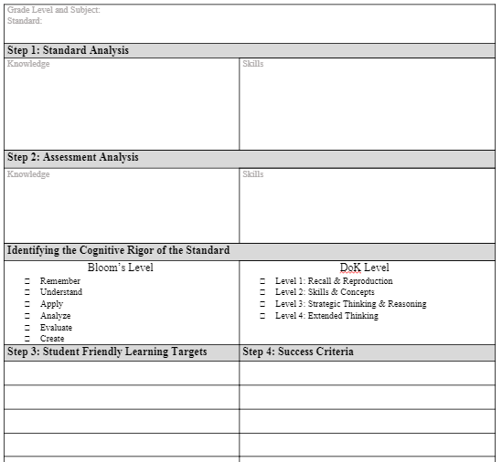

**Student Friendly Learning Targets:**

Teachers create **statements** that reflect the knowledge and skills necessary for students to be proficient in the standard, in a way that students can understand.

Learning targets are: ​

* Able to be accomplished in a few days (turned into daily objectives) ​
* Specific to what and how​
* Consists of concept, skill and often a specified context​
* Teachable/learnable using a variety of instructional activities, methods, strategies, tools, etc.; can apply to multiple contexts​
* One component in a sequence of scaffolded accomplishments- focused on what is to be learned

Tips for creating learning targets:

* Describe the knowledge and skills in a way that makes sense to the teacher and student. ​
* Using the Performance Level Descriptors (found in the Item Specifications Guide) as a guide, create statements from the embedded knowledge and procedural underpinnings of the standard. ​
* Minimally, there are four scaffolded learning targets in the item specifications document that can be used to support the development of additional learning targets.

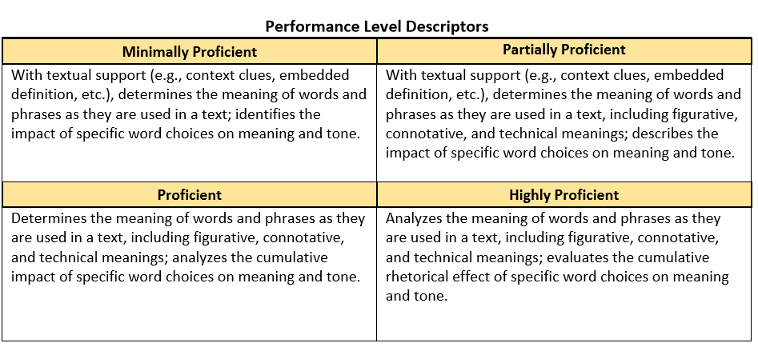

Resources:

|  |  |  |
| --- | --- | --- |
|  | Videos & Resources | Additional Readings |
| Student Friendly Learning Targets | Student friendly learning target overview and- [8th grade example](https://www.youtube.com/watch?v=FKlnx1ASSEA)  [Teacher clarity of learning goals](https://youtu.be/_GUF9JfOkfg)- Larry Ainsworth  [SWBAT](https://youtu.be/fx1ikG3hfzI): Communicating learning goals | [5 FAQs about Learning Goals and Learning Targets](https://blog.teacherspayteachers.com/faqs-learning-goals-learning-targets/)  By Hubbard's Cupboard  [Student friendly learning targets overview and 4-5 example](http://www.thoughtfulclassroom.com/Lorain/DesignForms/Student-Friendly_Learning_Targets.pdf)  [Making standards come to life: Learning Targets](https://justaskpublications.com/just-ask-resource-center/e-newsletters/msca/learningtargets/)  By Heather Clayton |

**Success Criteria:**

Teachers must describe **specific performance** that demonstrates meeting the learning target; they are concrete representations of the target; they represent a clear pathway for students; are a guide for students and teachers to determine if students are doing well. Describes anything a student can **say, do, produce, create or show** that they have met the **learning target**.

What are they? ​

* Guidelines that teachers and students can use to determine progress toward the goal​
* Criteria students can use to assess how closely their work matches their teacher’s expectations​
* Exemplars of excellence

Why are the important? ​

* Improves teacher and student understanding of the target​
* Empowers students to monitor their own learning ​
* Encourages independent learning​
* Enables accurate feedback​

Tips to Writing Success Criteria

* Use the Item Specifications Guide- task demands to help guide what students need to be able to do to demonstrate proficiency in the standard.

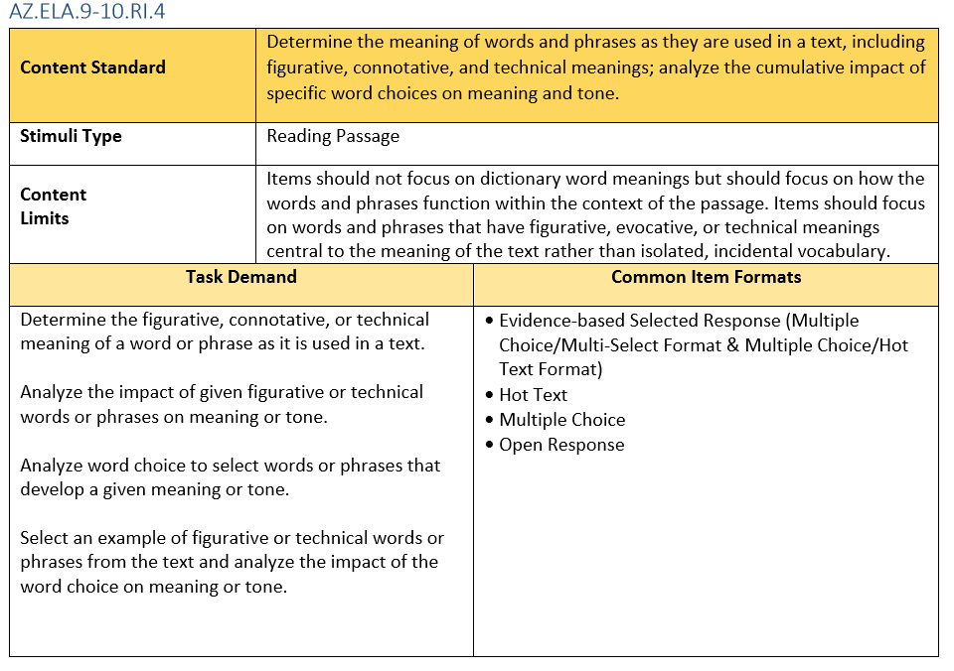

* Consider the following questions:
  + What would the standard, if mastered, look like in terms of student work? ​
  + What is the evidence we expect students to generate to demonstrate proficiency? ​

Resources:

|  |  |  |
| --- | --- | --- |
|  | Videos & Resources | Additional Readings |
| Success Criteria | Middle school example: [Developing Success Criteria](https://www.youtube.com/watch?v=eJ-RvrsZUSE)- Overview and examples    High school example: [Learning Goals Success Criteria](https://www.youtube.com/watch?v=3yMEiztTuEA) | [Planning Guidelines for Writing Learning Targets and Success Criteria](https://cse.wwu.edu/files/SMATE/SMATE%20Docs/Planning%20Guidelines%20for%20Writing%20Learning%20Targets%20and%20Success%20Criteriav3.pdf)  [Writing Tips for Learning Goals and Success Criteria](https://www.oregon.gov/ode/educator-resources/assessment/Documents/writing_tips_learning_goals_success_criteria.pdf)  [Spark Motivation in Your Students with Success Criteria.](https://www.teachingchannel.org/tch/blog/spark-motivation-your-students-success-criteria)  By Marine Freibrun |

**Step 2: Create lesson plans**

Outcome: Teachers will use the student friendly learning targets and success criteria (from the unpacked standards template) to create lesson/unit plans that communicate:

* 1. what students will learn (learning targets)
  2. what success looks likes (success criteria)
  3. the design of instruction, including strategies, activities and materials/resources, that will be used accomplish these goals
  4. assessments that will be used to measure and monitor learning

**Creating “daily objectives”**

1. Daily objectives represent smaller “chunks” of the learning target
2. They should be written in student friendly language
3. They should communicate to students: the new learning, the purpose and what success looks like
4. A format you could use for this is: **Today I will… (learning target) So I can… (relevance) I’ll know I have it when… (success criteria)**

**Example: Today I will** connect the ideas in my writing by using linking words (also, another, and, more, but, etc.). **So I can** clearly connect my opinion and reasons in my writing. **I’ll know I have it when** I can highlight the linking words in my writing and underline my opinions and reasons that they connect.

1. The following puts this process all together:

**Step 3: Creating Formative Assessments/Checks for Understanding**

Outcome: Teachers will create formative assessments aligned to learning targets and success criteria that result in feedback that can be used to drive decisions by the student and teacher.

**Formative Assessment Design Process- Integrated with AzM2 Resources**

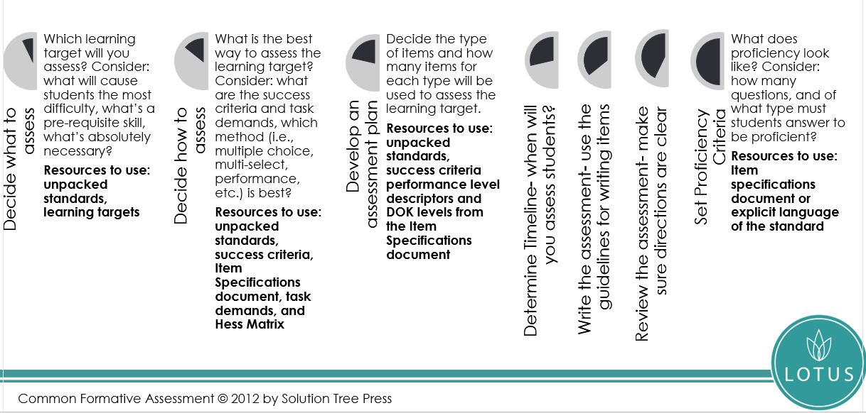

**Assessment Strategies Overview**

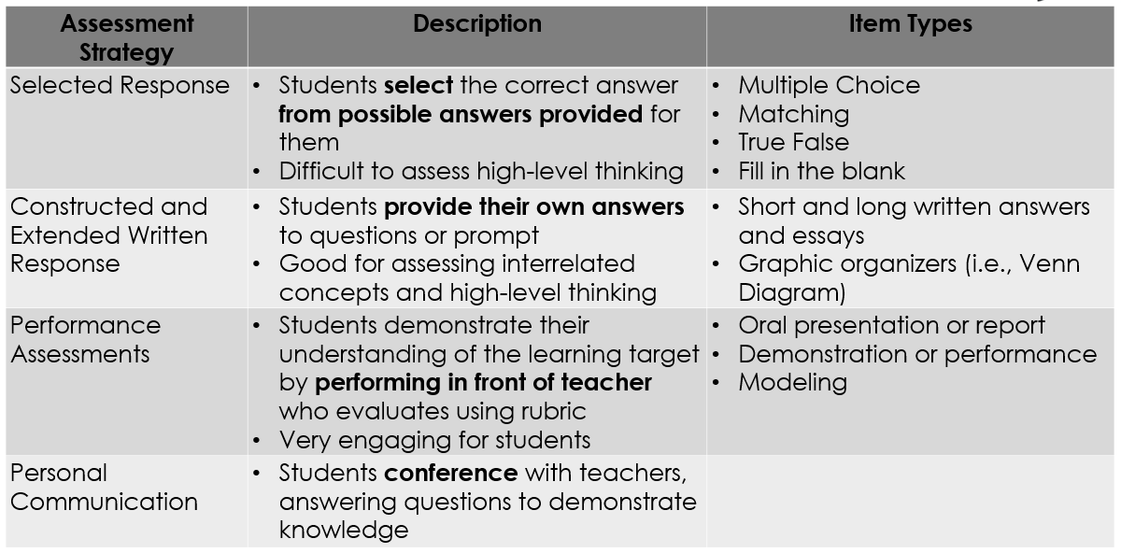

**Assessment Plan Tips**

* How many learning targets should you assess?
  + Rule of thumb: no more than four.
* How you will assess them?
  + Align the type of assessment(s) will you use for each learning target to the assessment types for AzM2 (if applicable).
  + Align the type of assessment(s) items to each of the performance levels of AzM2.
  + Use a variety of methods.
* How many items of each type will you need to assess each learning target?
  + Rule of thumb: at least three (total) for each learning target.
  + Be sure to assess at the level of rigor or the standard.

**Create an Assessment Plan**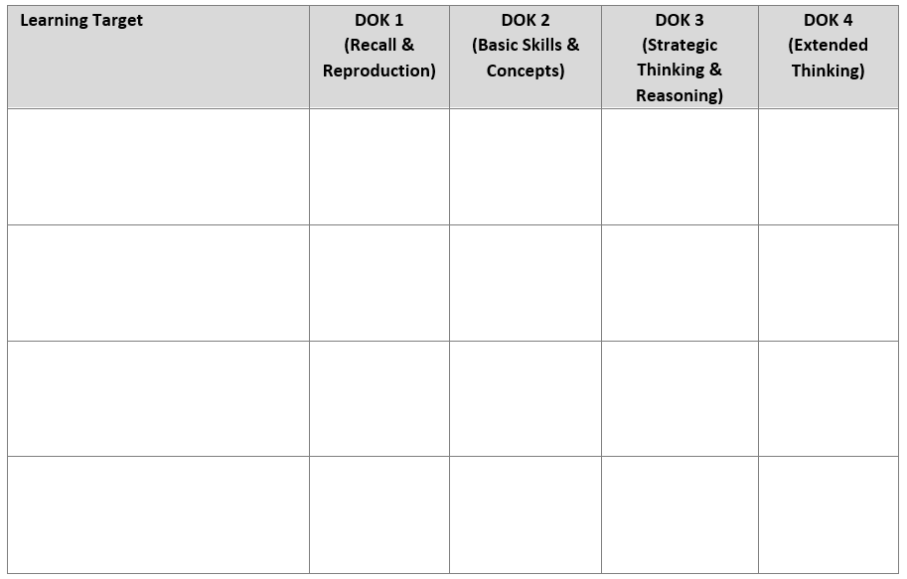

Example:

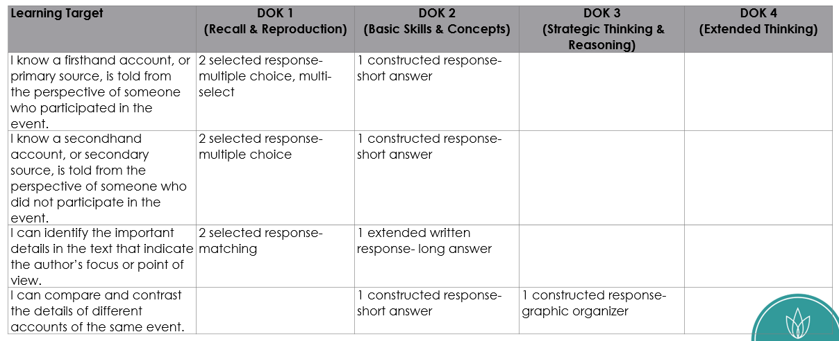

**Step 4: Utilize Data to Inform Further Action**

Outcome: Create action plans based on timely data that address the gaps in the effectiveness of curriculum and instruction, and learning needs of students.

|  |
| --- |
| Step #1: Relationships (1 minute)  Step #2: Observation of student data (15 min)  Step #3: Curriculum & Instruction evaluation (8 minutes)  Step #4: Curriculum & Instruction questions (2 minutes)  Step #5: Leaving with a task (5 minutes)  Step #6: Closing (2 minutes) |

**33 Minute Data Dialogue Overview**

**SMART Goals Overview:**

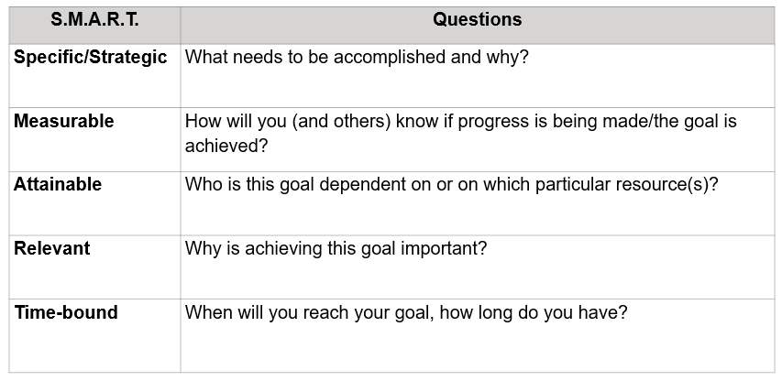

**Curriculum and Assessment Review Overview**:  
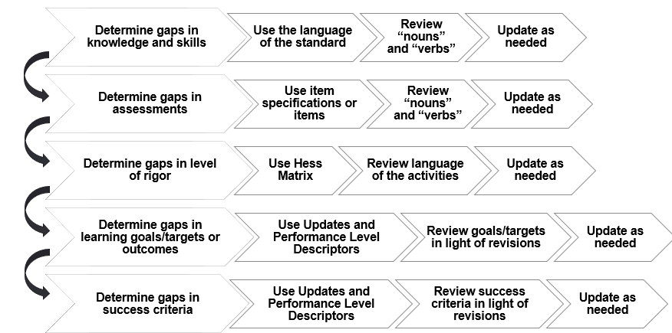

**Sample Reteach Action Plan**:

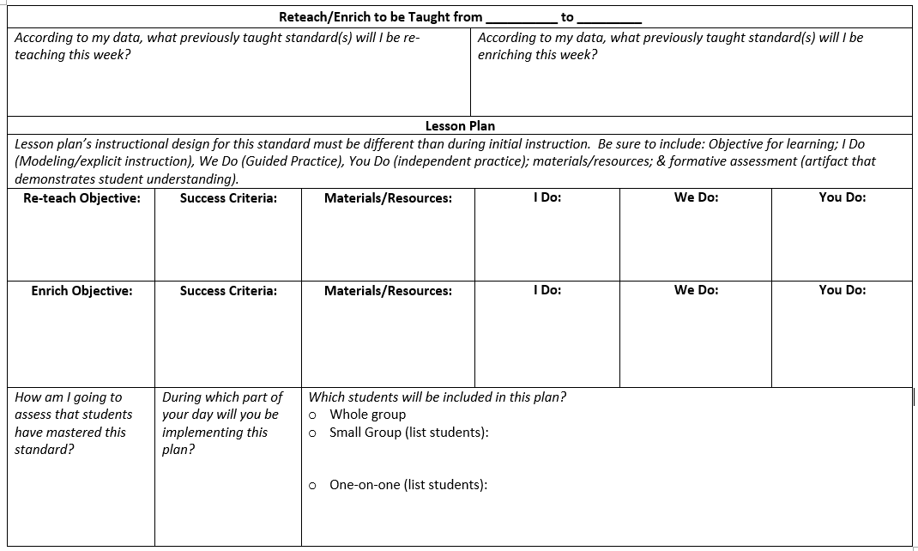

**AVID Strategies:**

**WICR**

**Socratic Seminar**

**Philosophical Chairs**

**Cornell Notes**

**Get the rest from Lisa**

**Overview of Response to Intervention**:

